**Dual Booting**

1. **Create a Dual boot system with 2 linux distributions - Ubuntu & Fedora.**

**Ans.** First, I installed Fedora on the VM and then Ubuntu on the same VM but on a different partition.

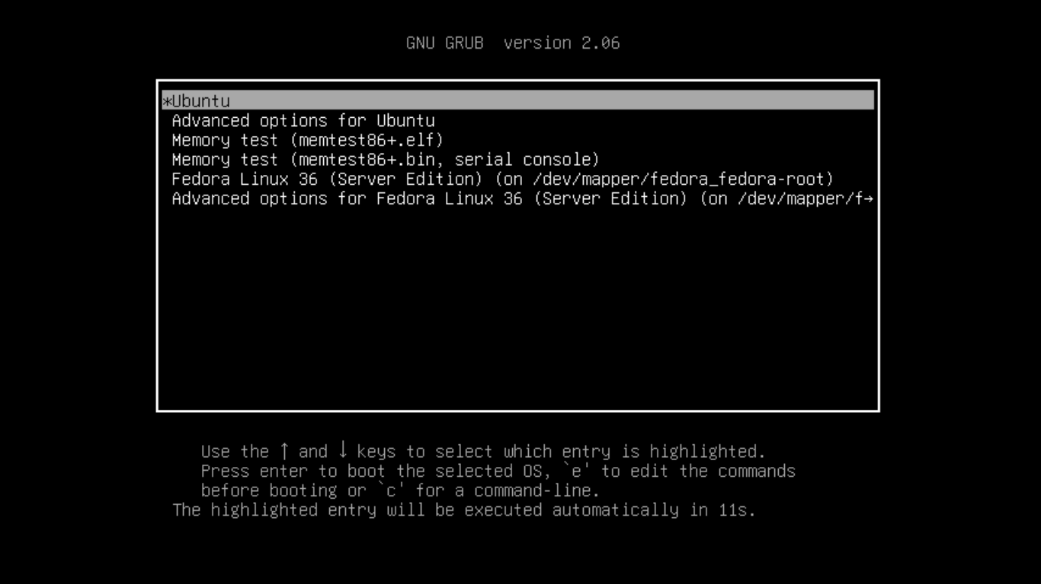

1. **Configure GRUB for waiting 15 seconds before booting the operating system by default if no key is pressed.**

**Ans.** I did it by following these steps:

vim /etc/default/grub

Changed GRUB_TIMEOUT=5 to GRUB_TIMEOUT=15

Applied the configuration by executing ‘update-grub’

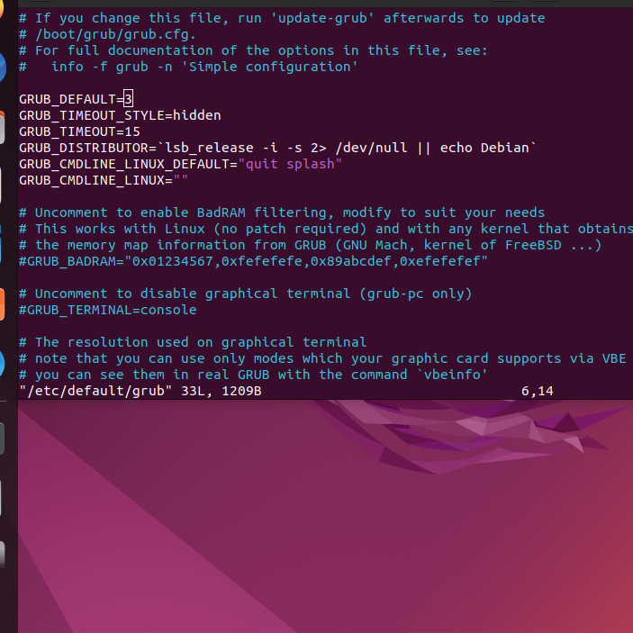

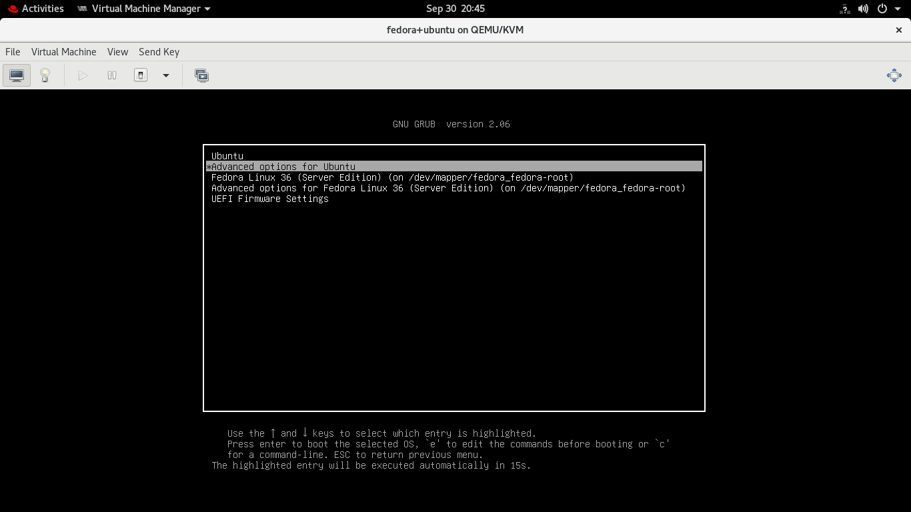

1. **Change the default Operating system**

**Ans.** I changed the default operating system in boot menu by following these steps:

vim /etc/default/grub

changed the line GRUB_DEFAULT=0 to GRUB_DEFAULT=saved

Applied the configuration by executing ‘update-grub’

Finally, set a default boot OS by executing ‘grub-set-default n’

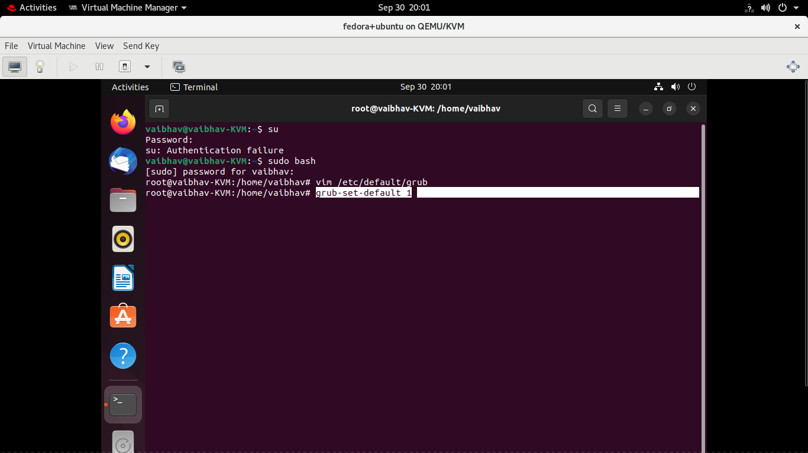

1. **Update the kernel of ubuntu.**

**Ans.** I updated the kernel by using following commands:

uname –sr

sudo apt-get update

sudo apt-get dist-upgrade

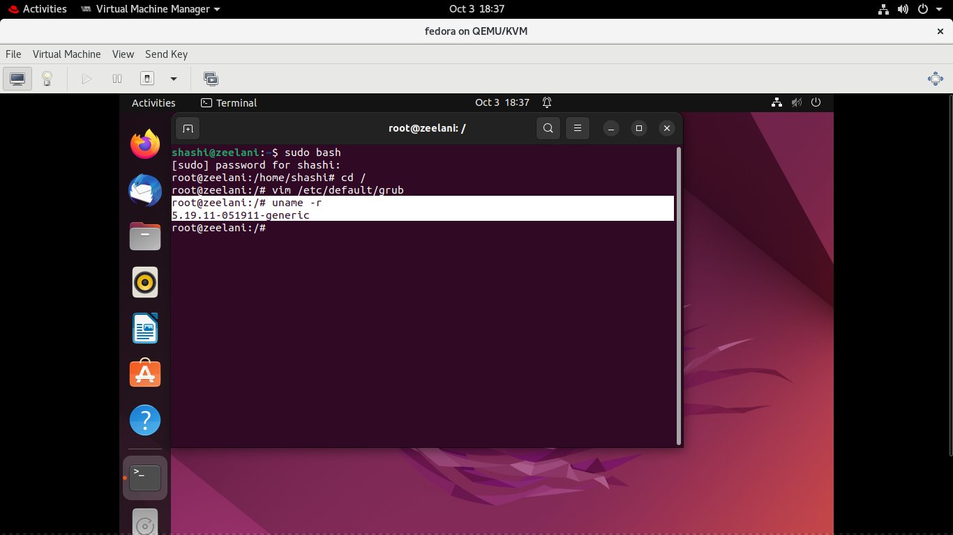

1. **Change the default kernel that boots with ubuntu**

**Ans.** I changed the kernel by following these steps:

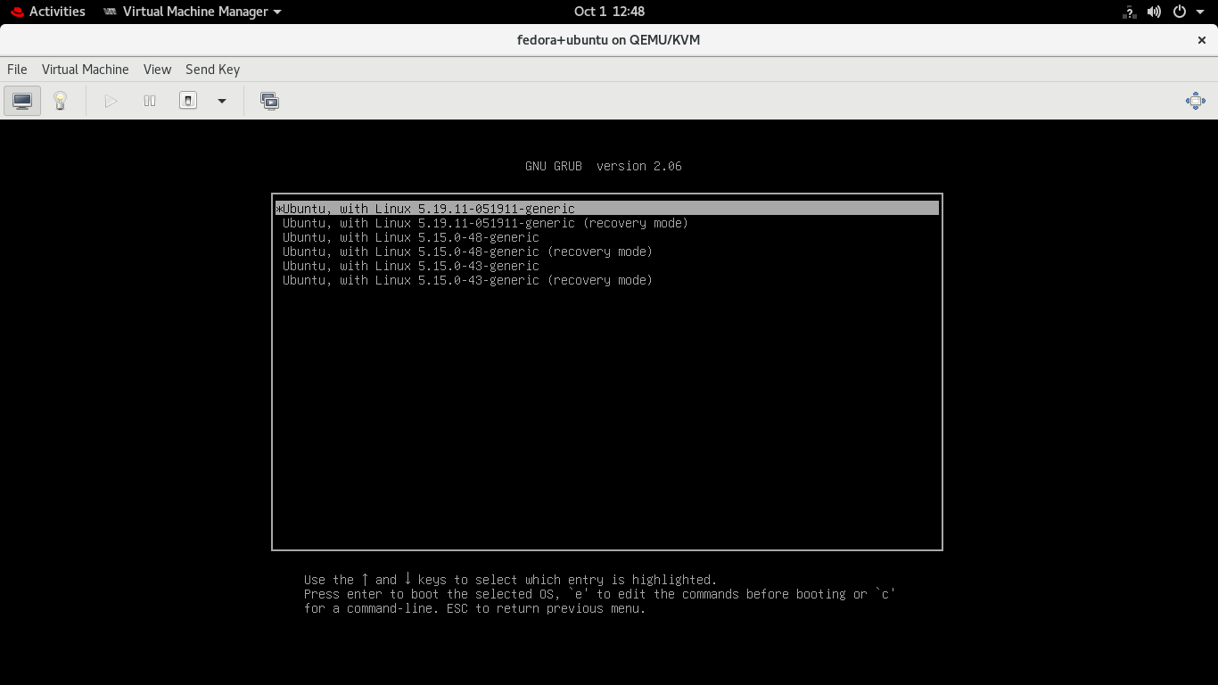

Src - https://linuxhint.com/install-upgrade-linux-kernel-ubuntu-linux-mint/

1. **How does BIOS work in virtual machines?**

**Ans.** We can get into BIOS by pressing the F2 key at the time of booting.

